SETTING UP APPLICATION ENVIRONMENT

CREATE AN ACCOUNT IN SEND GRID

|  |  |
| --- | --- |
| TEAM ID: | PNT2022TMID20238 |
| PROJECT TITLE: | PLASMA DONOR APPLICATION |

**STEP 1:** SIGNING UP FOR FREE

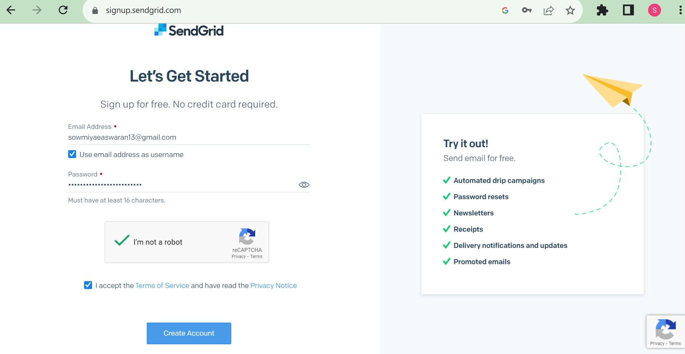**STEP 2:** ENTERING DETAILS

**STEP 3:** FINALLY YOU WILL HAVE TO WAIT FOR YOUR ACCOUNT TO GET SIGNED UP AND APROVED.